BELKNAP HOT SPRINGS, LODGE, AND GARDENS

WEBSITE & RESERVATION SYSTEM DESIGN DOCUMENT

Design By  
John Bell  
Cody Connor  
Yadira Despaigne  
Khawla Hafsia

© 2018 BELL, CONNOR, DESPAIGNE, HAFSIA

Table of Contents

Introduction ………………………………………………………………………. 2

Description ………………………………………………………………………. 2

User Experience Design …………………………………………………….. 3

* Existing Website Design …………………………………………….. 3
* Updated Website Design Mock-Up ……………………………………. 4
* Problems with Current Reservation System …………………………… 5
* Problems with the Current User Interface …………………………… 6
* Navigation Hierarchy for New Website ………………………….... 7

System Requirements ……………………………………………………... 10

* Functional Requirements …………………………………………….. 10
* Non-Functional Requirements ……………………………………. 11
* Implementation Requirements ……………………………………. 11
* Supportability Requirements …………………………………………….. 11

Data Design ………………………………………………………………………. 13

* Entities …………………………………………………………….... 13
* Attributes ………………………………………………………………. 13
* Conceptual ERD ……………………………………………………… 15
* Logical ERD ………………………………………………………………. 16

Use Cases ……………………………………………………………………….. 17

* Rental Lookup System Use Case …………………………………….. 17
* Reservation System Use Case …………………………………….. 17
* Account System Use Case ……………………………………………… 18
* Content Management System Use Case ……………………………. 18
* Customer Relationship Management System Use Case …………… 19
* Reporting System ………………………………………………………. 19

Use Case Diagrams ……………………………………………………………….. 20

* Rental Lookup System Use Case Diagram …………………………….. 20
* Reservation System Use Case Diagram …………………………….. 21
* Account System Use Case Diagram ……………………………………… 22
* Content Management System Use Case Diagram ……………………. 23
* Customer Relationship Management System Use Case Diagram ….. 24
* Reporting System Use Case Diagram …………………………….. 25

Introduction

For the capstone project our group is going to recreate the site for Belknap Hot springs and lodge. The current site was created by a student 10 years ago and it has a lot of problems. The site is mainly a static site with information about the lodge but the site is using a third party reservation system so users can book a place to stay.

Description

The new site will be a responsive site created with asp.net mvc. The website will also contain a database that will store data for the reservations system.

About the reservations system

The current booking system allows users to search for available places to stay at belknap springs in a certain time period. The booking system has the user enter the property they want to stay at, the date they want to arrive, the date they want to leave, the amount of guests and children who are staying at the property, the type of reservation, promotional codes and any filters. The two properties that are available are belknap hot springs and garden and camp yale. The max amount of guests or children is 20, the types of reservations are RV/tent site and Lodge/Cabins MT Homes, and some of the available room type filters are River View, deck and pet friendly. The reservation type rv and tent site also gives you an option to find available sites with a certain site type and a certain site length.

User Experience Design

Current Site

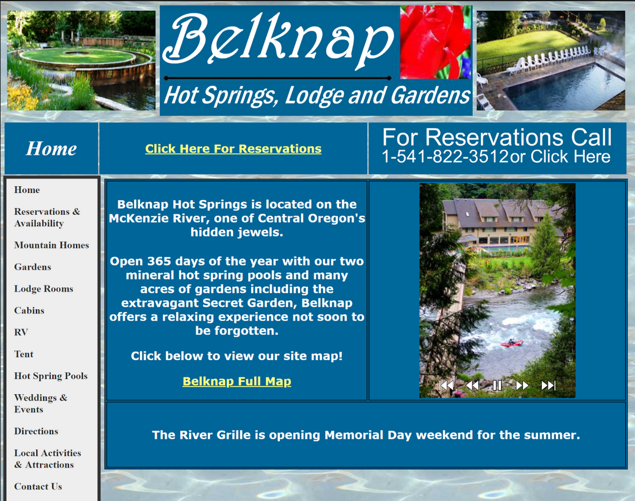

New Website Mockup

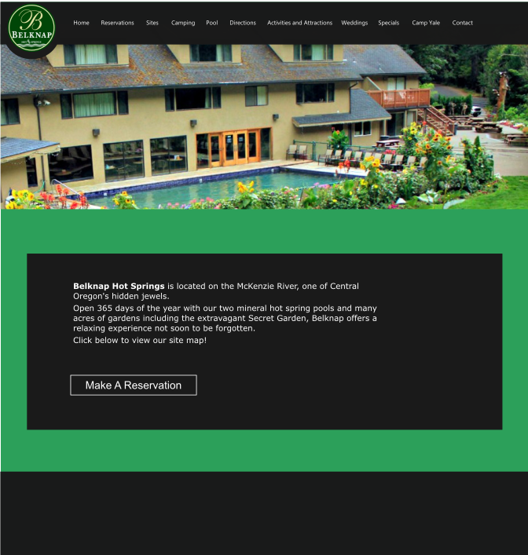

Change the design of the reservation page menu to look better (airbnb website is a good example of reservation page menu )

Problems with the current user interface

The current site uses flash to display images and play animation. Some browsers don’t show a lot of the information on the site because a lot of browsers are not longer using flash. The new site will not use flash. Any image galleries will be created with css, javascript or will be changed to image galleries.

The current site is not responsive and is hard to view other devices. The new site will be created with bootstrap so that they website can be viewed easily on multiple devices.

On the current site the navigation bar changes depending the the page the user is currently on. The new site will have a horizontal bootstrap navbar that will be the same for each page that the user visits.

Problems with current reservation system

The current reservation system shows all the rooms that are available at belknap springs for every search. The new reservation system should only show the available rooms so the user doesn’t have to look through rooms that are not available every time they try to search for an available site.

After testing the current reservation system for a while I noticed that it is very difficult to find a room that is available and being able to pay for it.

Existing Pages

* Navigation
  + Home -- contains general information and link to map, time based news (e.g. holiday info)
  + Gardens -- images of gardens
  + Lodge Rooms -- images, descriptions, max occupants, and price for different rooms, extra charges
  + Cabins -- same info as lodge rooms, but with cabins
  + Camping
    - RV -- info: rv slot #, length, location, check in, check out, water, electric, sewer, addtl fees and taxes, site map
    - Tent -- site name, location, #, drive up / walk in, check in and check out, price, fees and taxes, site map
  + Hot Spring Pools -- images, fee amounts, rules, mineral content listing
  + Weddings & Events -- site, photo, info, price
  + Directions -- has hand drawn map image and text directions from surrounding freeways
  + Local Activities -- bullet points of highlights, then listing of nearby restaurants, recreations, etc.
  + Contact Us -- list of different contact info, email addresses, phone numbers, address, etc
  + Reservations -- currently uses 3rd party booking system
  + Specials -- link just goes to reservations page
  + Camp Yale -- sister property, mountain homes and rv camping stuff similar to that of regular listing
    - Mountain Homes
    - RV Camping

Navigation Hierarchy For New Website

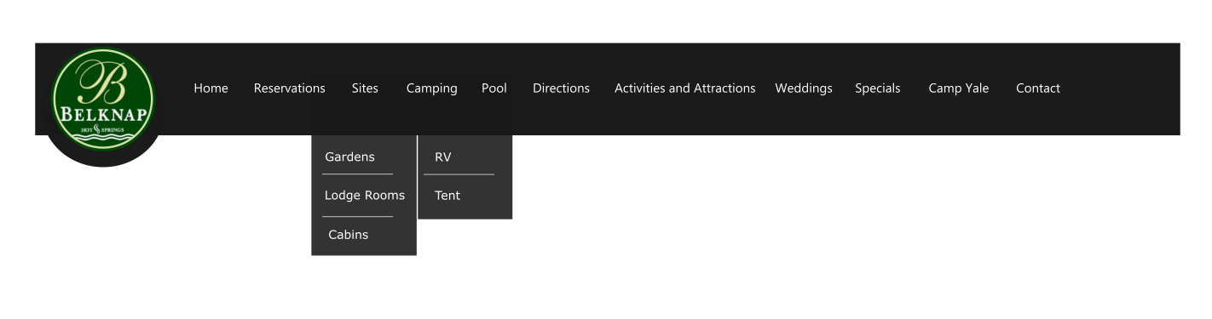

* Home
  + The site home page should give an introduction to Belknap Hot Springs and make it easy to get to the reservation system process.
* Reservations and availability
* Sites
  + Lodge rooms
  + Cabins
  + Camping
    - RV
    - Tent
* Gardens
* Hot Springs Pool
* Directions
* Local Activities and Attractions
* Weddings
* Contact
* Specials
* Camp Yale
  + Mountain Homes
  + Rv Camping
* Dining
  + This page will include available dining services information and hours of operation, for example: catering to the rooms, big table reservations,
* Things to Do
  + This page will include things guests can do and places they can go to while in tow. It’s understandable that not everyone who visits the springs is familiar with the area and need kind of like a guide or point to start from.
* Contact
  + The contact page will contain forms to contact belknap springs for general information and wedding information. The contact page will also display the businesses phone number mailing address and hours of operation.
* Reviews
  + A new page will be added to the site that will allow users to leave reviews about their stay at belknap hot springs and lodge.

System Requirements

Functional Requirements

* The system shall allow guests to view:
  + Property Amenities
  + Nearby Attractions
  + Location & Directions w/Waze and Google Maps Nav Links
  + All Cabins, RV Sites, Tent Sites, Lodges, Etc
  + Current events and special offers
  + Mineral content of the hot springs
* The system shall allow guests to:
  + Find availability of rental sites, cabins, etc
  + Reserve available rental sites
  + Pay for reserved bookings via third party payment system
  + Contact customer service
  + Contact wedding booking specialists
  + Register and leave reviews on site locations, amenities, etc.
* The system shall allow administrators to:
  + Manually add reservations for phone/walk in calls.
  + Manually edit reservations
  + Add scheduled events or special offers
  + Add notifications or special notices for unusual area activities, eg wildfires, weather problems, or other things that may interfere with visiting guests
  + Adjust water mineral content listings
  + Add relevant news stories or other content (blog)
  + Update page content
  + Create, Edit, or Delete available site listings.

Non-Functional Requirements

* The system must be reliably accessible across multiple devices.
* The website needs to be aesthetically appealing with the aim of generating guest reservations.
* The system will not store payment data in the database.

Implementation Requirements

* The system must use C# with the ASP.NET CORE 2 MVC Framework
* The system needs to use secured networks for transfering customer information
* The system will rely on a MSSQL Server RDBMS
* The system must encrypt and hash database content whenever possible to maximize the security of customer information
* The system will use HTML, CSS, jQuery, and Bootstrap to support it’s UX design and responsive design elements
* WCAG2 & 508 Accessibility Compliance

Supportability Requirements

* The system will be set up and tested by the development team.
* The system needs to require little or zero maintenance or upkeep as the initial agreement does not include a maintenance or support plan.
* All content and functions need to be editable and manageable by the on-site administrator associated with the client company.
* Basic instruction on how to restart the web server system in case of minor faults will be necessary for client self-administration, along with basic troubleshooting tips.
* Provide available resource list to the client so they have direction to in the event the system needs updated or upgraded.

Data design

New Reservation system Entities:

* Property
* Site
* Site_Type
* User
* Payment
* Search

New Reservation system Attributes

* Search_Filter_ID
* Property_Name
* Arrival_Date
* Departure_Date
* Promotional_Code
* Guest_Amount
* Child_Amount
* Search_Filters
* Site_ID
* Site_Name
* Availability
* Rate_Description
* Full_Rate
* No.OfArea
* Site_Type_ID
* Site_Type_Name
* User_ID
* User_Name
* Payment_ID
* Price
* Payment_History
* Property_ID
* Property_Name

New Reservation System Business Rules:

A search_filter searches through 1 to many sites

A site can match 0 to many search filters

A site has one and only one site type

A site type can apply to 0 to many sites

A user can make 0 to many payments

A payment is made by one and only one user

A payment is made to one and only one site

A site can have 0 to many payments

A property has 1 to many sites

New Reservation System Conceptual Entity Relationship Diagram

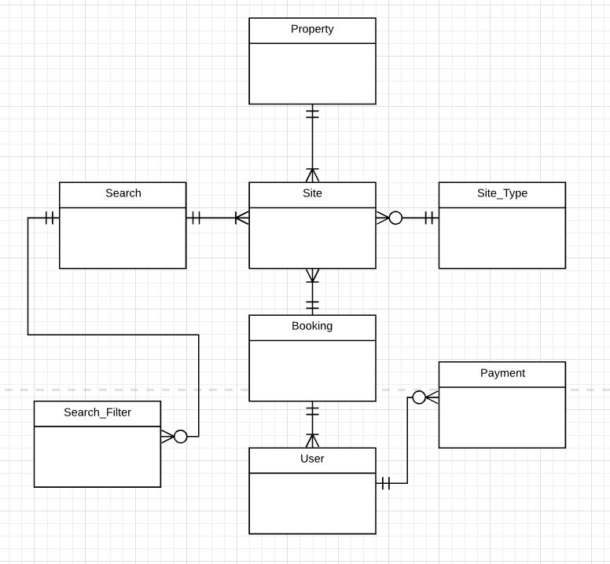

New Reservation System Logical Entity Relationship Diagram

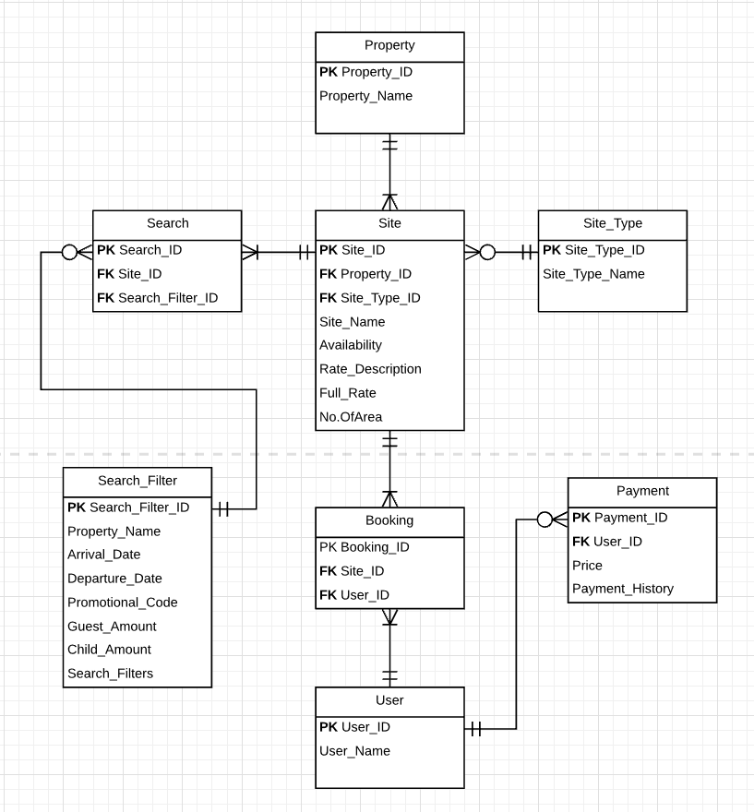

Use Cases

|  |  |
| --- | --- |
| **Rental Lookup System** | |
| **Use Case** | **Actors** |
| View All Rentals | Customer |
| Filter Rentals by Type or Availability | Customer |
| Select individual Rentals and view its features and availability. | Customer |
| Update Rental information | Administrator |
| Add Reviews to Rentals | Customer |
| Moderate Reviews | Administrator |

|  |  |
| --- | --- |
| **Rental Reservation System** | |
| **Use Case** | **Actors** |
| Book Available Rooms | Customer |
| Pay for Booking | Customer |
| Modify Bookings | Administrator |
| View Historical Booking Information (This time LW, LY, etc to see trends) | Administrator |
| Manually Add Bookings from Telephone or Walk In | Administrator |
| Update Booking Status | Administrator |

|  |  |
| --- | --- |
| **Content Management System** | |
| **Use Case** | **Actors** |
| View News Stories, Updates, Special Offers, and Events | Customer |
| Create News Stories, Updates, Special Offers, and Events | Administrator |
| Edit News Stories, Updates, Special Offers, and Events | Administrator |
| Delete News Stories, Updates, Special Offers, and Events | Administrator |
| Comment on News Stories, Updates, Special Offers, and Events | Customer |
| Moderate comments on News Stories, Updates, Special Offers, and Events | Administrator |

|  |  |
| --- | --- |
| **Account System** | |
| **Use Case** | **Actors** |
| Register an Account | Customer |
| Edit Profile | Customer |
| View Purchase History | Customer |
| Cancel Account | Customer |
| Suspend Account | Administrator |
| Link Account to Social Media | Customer |

|  |  |
| --- | --- |
| **Customer Relationship Management System** | |
| **Use Case** | **Actors** |
| Receive Report Data on Overall Customer Activity | Administrator |
| View All Customers | Administrator |
| Lookup Customers data -- examples include who reserved the most, most purchases, reserved least. | Administrator |
| Create or Edit automatic email follow-up system | Administrator |
| Create email triggers, such as after x number of reservations, or x days since last reservation, etc. | Administrator |
| Receive Customer Sales Reports | Administrator |

|  |  |
| --- | --- |
| **Reporting System** | |
| **Use Case** | **Actors** |
| View reports on website activity | Administrator |
| View reports on sales activity and trends | Administrator |
| Receive notifications and view reports on comments, encourage follow-up | Administrator |
| Receive weather system alerts via web API | Administrator |
| Use Google Analytics to aid in SEO if desired | Administrator |
| View reports on account registration and activity | Administrator |
| View reports on automated email activity | Administrator |
| Receive notifications daily, and view daily booking summaries, including bookings scheduled previous day and bookings that are to arrive on current day. | Administrator |

**Use Case Diagrams**

Rental Lookup System Use Case Diagram

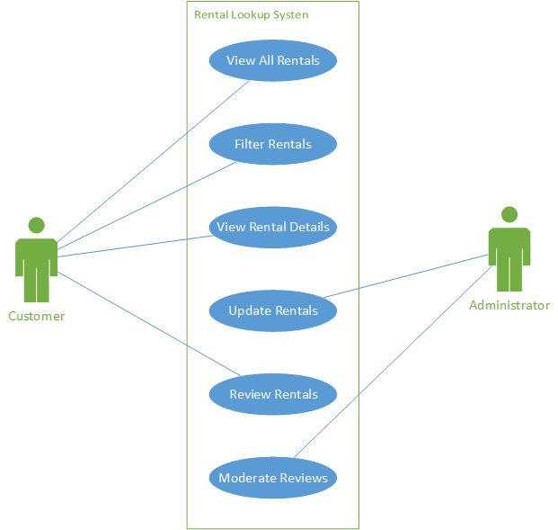

Reservation System Use Case Diagram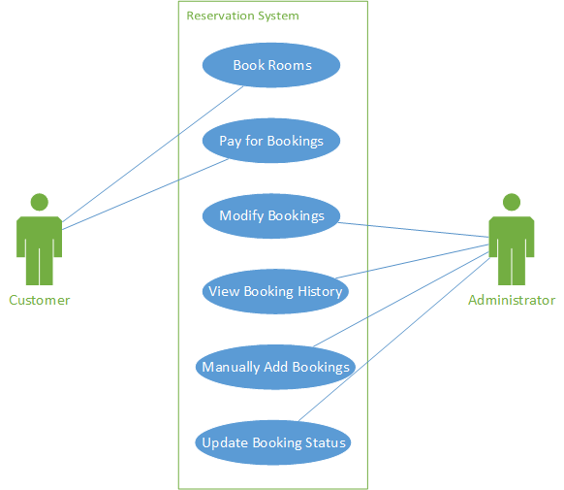

Content Management System Use Case Diagram

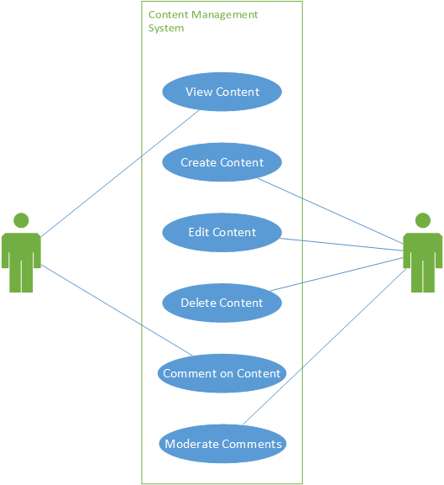

Account System Use Case Diagram

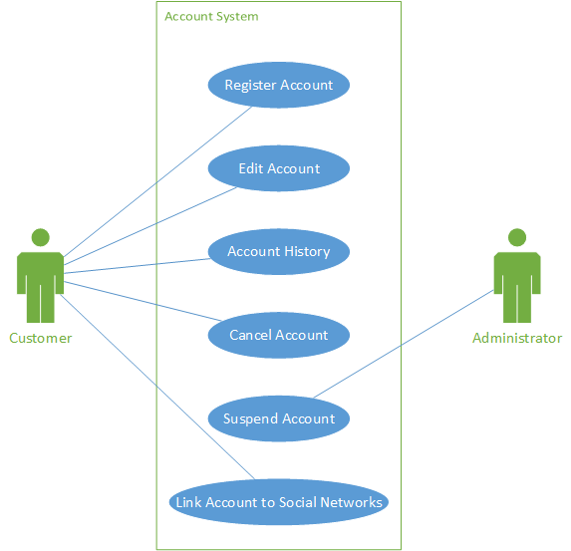

Customer Relationship Manager System Use Case Diagram

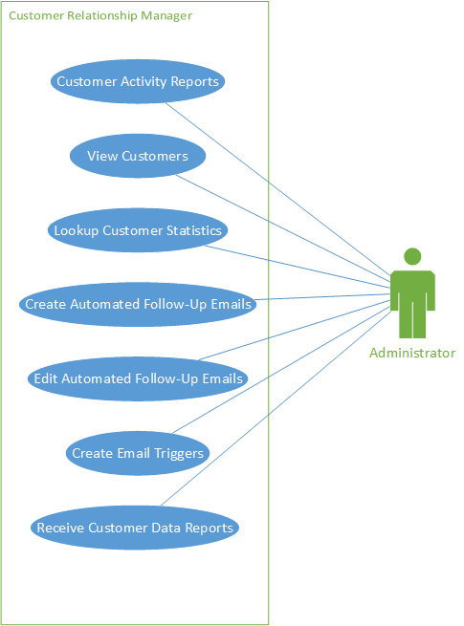

Reporting System Use Case Diagram

